GREAT Source For US Navy Ship’s Ballcaps
Note: There were NO kickbacks or secret money transfers received as a result of this article…..just a GREAT product!!
Just ordered a cotton twill, made in the USA, USS Leahy embroidered, low profile (Old Salt Type) ballcap (shown below). They also have the higher profile ballcaps.
https://www.militarygifts.com/OldSaltCap
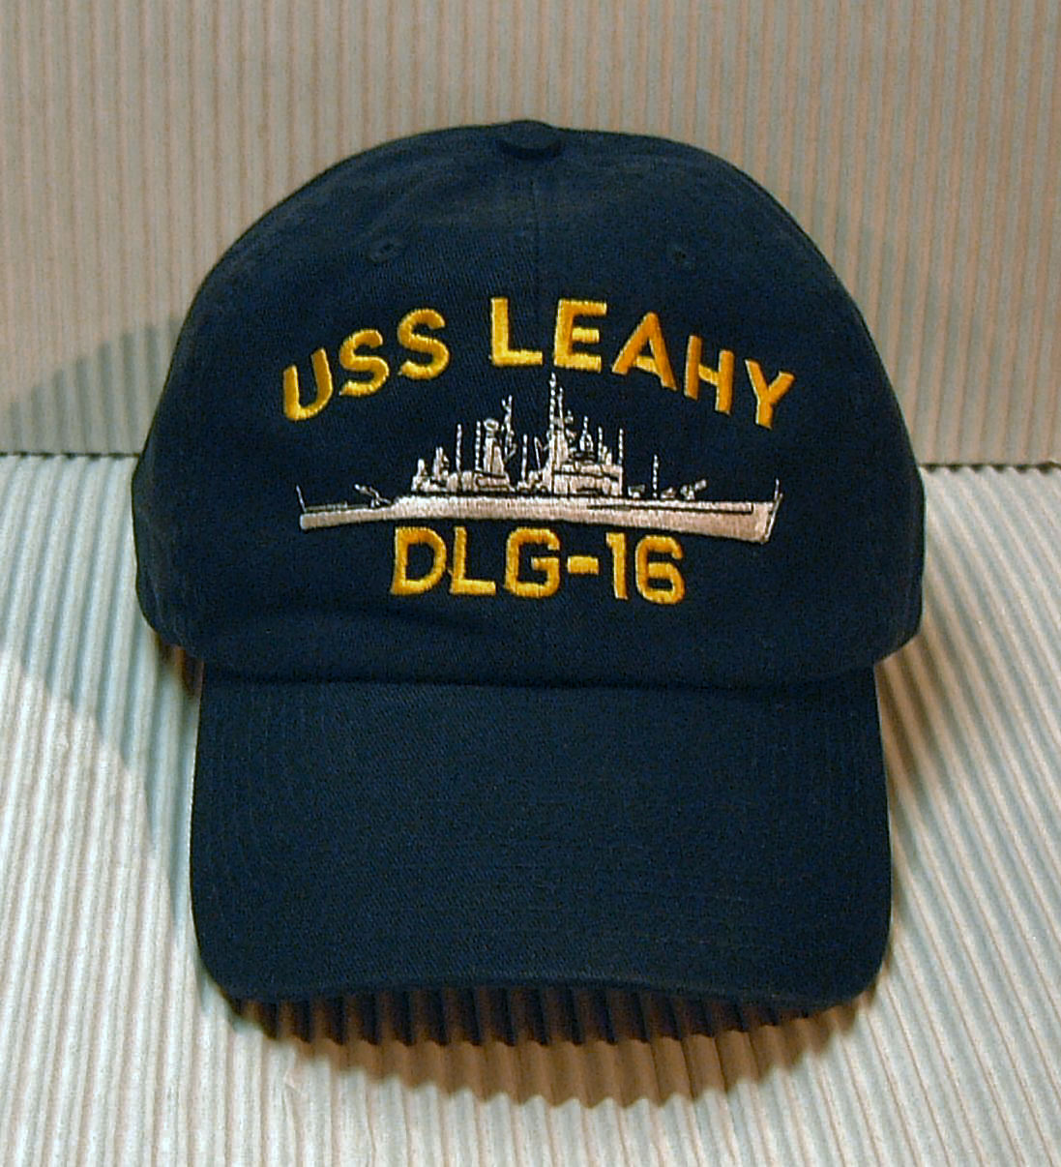
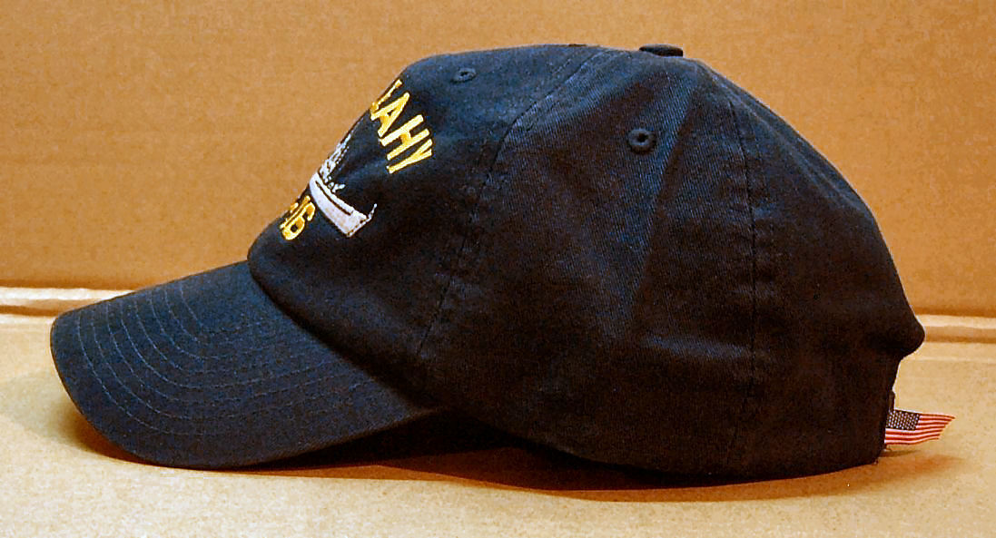
Ordered from this mom-and-pop source* from a young lady named Terry. Received it in less than a week, priority mail. A little pricey but well worth it.

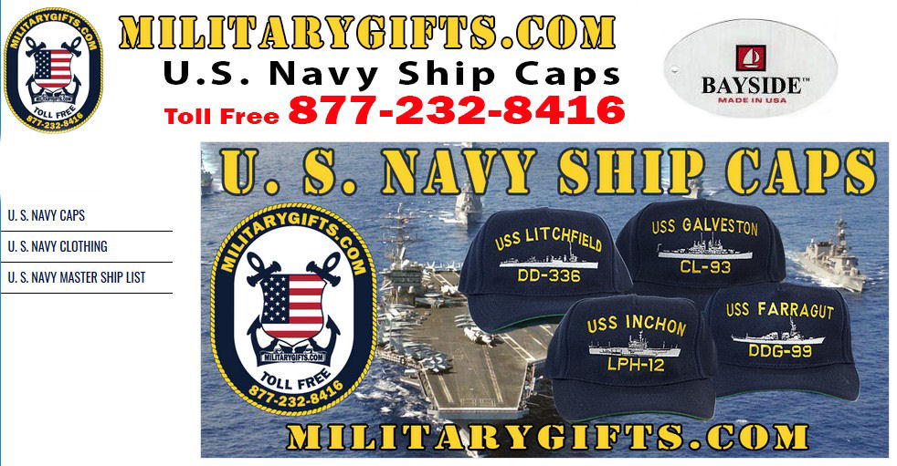
Standard “high profile” ballcaps are shown above.
https://www.militarygifts.com/RegulationCap

They also supply US Navy monogrammed clothing.
https://www.militarygifts.com/U-S-Navy-Clothing_c_1.html

*At militarygifts.com , we are a small family business, located in Upstate New York. For more than 25 years we have offered custom embroidered U.S. Navy Ship Caps and more. None of our products are sitting on a warehouse shelf, collecting dust - Each item we make is custom embroidered for you! We specialize in the single cap order - that's right, or minimum order is just one cap or shirt. If you have been looking all over for a cap for your old U.S. Navy Ship, you have found THE SOURCE for your needs.

