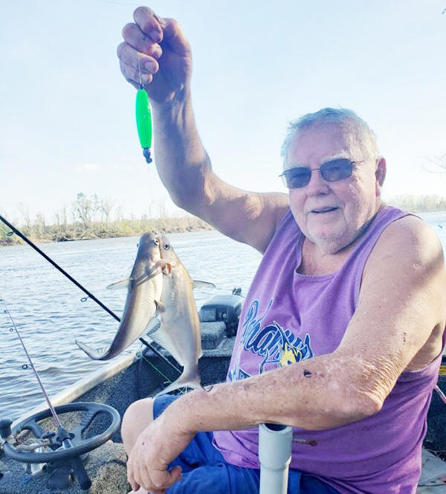
HERBERT RAY VARNUM
BRISTOL - Herbert “Ray” Varnum, 76, of Bristol, passed away from this life on April 30, 2023. Ray was born on August 15, 1946 in Blountstown to Leia Mae Griffin and his loving stepfather, Morris Mitchell. Ray was unexpectedly diagnosed with a terminal brain tumor in January. He passed quietly from this life holding Mary Ellen’s hand while she reminisced about the good days and his future "fishing in Heaven days”!
Ray graduated from Blountstown High School in 1965 where he played both basketball and football for the Tigers. Ray was raised with his younger brother, Tommy, who was his first and forever best friend until he passed away in 2010, and his sister Ruby, who always tried to "tag along" with the big brothers. As adults Ray, Tommy and Ruby enjoyed so many fishing trips, shared a family houseboat and loved traveling!
After high school, Ray enlisted in the United States Navy where he proudly served his country and completed a tour in Vietnam where he specialized as a Gunner. He was responsible for operating and maintaining missile launch systems as well as gun mounts on helicopters.
Ray met and married Linda and had three beautiful children, Belinda Rae, Dale and Randy. They were married for over 35 years until her passing in 2004. They settled in Liberty County and Bristol became the family hometown. The kids grew up from birth to adulthood on riverbanks, fishing boats, houseboats and sand bars and all love fishing to this day. Fishing was Ray’s passion and if he was not fishing, he was talking about it. His favorite type of fishing was "whatever is biting”! He received weekly calls asking where the fish were biting and he never minded sharing a favorite fishing hole.
After returning home from the Navy, Ray had a long career in construction. He eventually became employed with the Florida Department of Corrections and retired as Construction and Maintenance Superintendent at Liberty Correctional Institution in 2010. Ray met his wife, Mary Ellen, in prison (this has always been their story). They met while employed at Liberty Correctional Institution and married in 2006. After marriage, when not fishing, they became avid travelers as a couple and often with amazing friends and family. They spent 13 years of retirement traveling. Some of the highlights for Ray were visiting The Vietnam Veterans Memorial, the Pearl Harbor National Memorial, the Pentagon, The White House, Niagara Falls and most importantly, riding the Golden Escalator where Donald Trump kicked off his bid for president. Ray became a President Trump Supporter before most and wishes he could vote from Heaven.
Ray and Mary Ellen attended the Fusion Church in Bristol where Ray was saved by Jesus and later baptized by Brother Darrell Johnson, making today a true celebration of not only Ray’s past life, but his final chapter. He loved gardening, working in his wood shop and could and would build anything.
Ray was an incredible friend to so many local folks and missed very few afternoons at the “Table of Knowledge”, liars table at the local restaurant.
Ray is survived by his wife, Mary Ellen Varnum; his children, Belinda Rae Varnum, Ronald “Dale” Varnum (Lisa) and Randy Allen Varnum (Karra), all of Bristol; One stepdaughter, Kaycee Durden (Lance), of Hosford; One sister, Ruby Wells (Carl), of Tallahassee; his grandchildren, Dillion Varnum (Allie), Casey and Colby Brantley, Darren Varnum, Toby Varnum, Samantha Sheffield and Richard John Durden; nieces, Cheryl Varnum Rowe (Chuck) and Carol Varnum Bush (Mike); nephews, Tommy Ray Varnum and Chris Wells (Wendy) and many great-grandchildren, great-nieces and nephews, and cousins.
Ray was preceded in death by his first wife and mother of his children, Linda Faye Eubanks Varnum; his mother, Leia Mae Griffin; stepfather, Morris Mitchell; grandmother, Froni Barton Griffin; grandfather, John “Tom” Griffin and brother, Thomas “Tommy” Varnum.
Visitation will be held Monday, May 8 at 11 a.m. until service time at 12 p.m. at the Fusion Church in Bristol. A reception will follow the service at the church.
Charles McClellan Funeral Home in Quincy, Florida is in charge of arrangements.

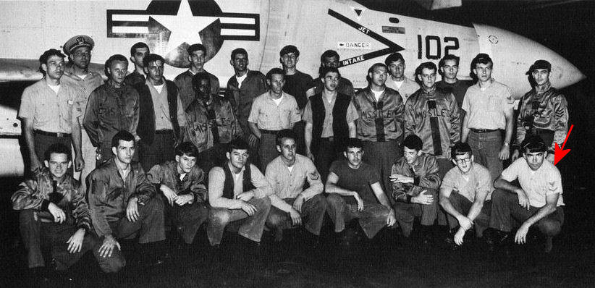
Guided Missile Division USS Saratoga (CVA-60)

